Unit 3 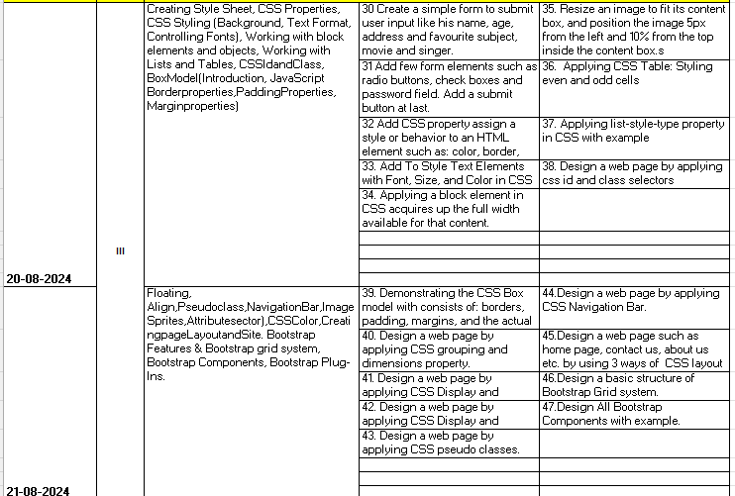

Program list
31 Add few form elements such as radio buttons, check boxes and password field. Add a submit button at last.
32 Add CSS property assign a style or behavior to an HTML element such as: color, border, margin and font-style.
33. Add To Style Text Elements with Font, Size, and Color in CSS
34. Applying a block element in CSS acquires up the full width available for that content.
35. Resize an image to fit its content box, and position the image 5px from the left and 10% from the top inside the content box.s
36. Applying CSS Table: Styling even and odd cells
37. Applying list-style-type property in CSS with example
38. Design a web page by applying css id and class selectors
39. Demonstrating the CSS Box model which consists of: borders, padding, margins, and the actual content.
40. Design a web page by applying CSS grouping and dimensions property.
41. Design a web page by applying CSS Display and Positioning property.
42. Design a web page showing the use of inline, internal and external CSS.
43. Design a web page by applying CSS pseudo classes.
44.Design a web page by applying CSS Navigation Bar.
45.Design a web page such as home page, contact us, about us etc. by using 3 ways of CSS layout
46.Design a basic structure of Bootstrap Grid system.
47.Design All Bootstrap Components with example.

PROGRAM 30
a. Create a simple form to submit user input like his name, age, address and favourite subject, movie and singer.

<!DOCTYPE html>
<html>
<head>
<title>User Input Form</title>
</head>
<body>
<h1>User Input Form</h1>
<form action="process_form.php" method="post">
<label for="name">Name:</label>
<input type="text" id="name" name="name" required><br>

<label for="age">Age:</label>
<input type="number" id="age" name="age" required><br>

<label for="address">Address:</label>
<input type="text" id="address" name="address" required><br>

<label for="subject">Favorite Subject:</label>
<input type="text" id="subject" name="subject" required><br>

<label for="movie">Favorite Movie:</label>
<input type="text" id="movie" name="movie" required><br>

<label for="singer">Favorite Singer:</label>
<input type="text" id="singer" name="singer" required><br>

<input type="submit" value="Submit">
</form>
</body>
</html>
output
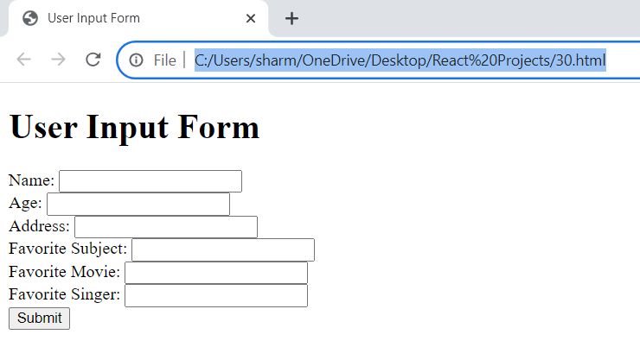

b. Create a simple form to submit user input like
his name, age, address in css

program B
<!DOCTYPE html>
<html lang="en">
<head>
<meta charset="UTF-8">
<meta name="viewport" content="width=device-width, initial-scale=1.0">
<link rel="stylesheet" href="styles1.css">
<title>User Input Form</title>
</head>
<body>
<form>
<label for="name">Name:</label>
<input type="text" id="name" name="name" required>

<label for="age">Age:</label>
<input type="number" id="age" name="age" min="1" max="120" required>

<label for="address">Address:</label>
<textarea id="address" name="address" rows="4" cols="50" required></textarea>

<input type="submit" value="Submit">
</form>
</body>
</html>

Css Styling (styles1.css)
form {
width: 300px;
margin: 0 auto;
padding: 20px;
border: 1px solid #ccc;
border-radius: 5px;
}

label {
display: block;
margin-bottom: 5px;
}

input[type="text"],
input[type="number"],
textarea {
width: 100%;
padding: 10px;
margin-bottom: 15px;
border: 1px solid #ccc;
border-radius: 3px;
}

input[type="submit"] {
background-color: #4CAF50;
color: white;
padding: 10px 20px;
border: none;
border-radius: 3px;
cursor: pointer;
}

Explanation
HTML Structure
- Form elements:
  - <form>: Defines a form for user input.
  - <label>: Associates labels with form elements for accessibility.
  - <input>: Creates different input fields (text, number).
  - <textarea>: Creates a multi-line text input area.
  - <submit>: Creates a submit button to send the form data.
CSS Styling
- Form styling:
  - Sets width, margin, padding, border, and border radius for the form.
- Label styling:
  - Sets display to block for proper layout and adds margin bottom for spacing.
- Input and textarea styling:
  - Sets width, padding, margin, border, and border radius for input fields and textarea.
- Submit button styling:
  - Sets background color, text color, padding, border, border radius, and cursor for the submit button.
Additional Considerations
- Form validation: You can add JavaScript to validate user input before submission.
- Styling: Customize the CSS further to match your desired design.
- Accessibility: Ensure proper use of labels and ARIA attributes for accessibility.
- Security: Implement appropriate security measures to protect user data.
This code provides a basic form structure with basic styling. You can expand on this by adding more form elements, customizing the appearance, and implementing form validation.

Note in last code part
Selector:
- input[type="submit"]: This part of the CSS targets any input element whose type attribute is specifically set to "submit". In simpler terms, it selects submit buttons.
Properties and Values:
- background-color: #4CAF50;: Sets the background color of the submit button to a green color represented by the hexadecimal code #4CAF50.
- color: white;: Sets the text color of the button to white.
- padding: 10px 20px;: Adds padding to the button. The first value, 10px, is for the top and bottom, and the second value, 20px, is for the left and right. This creates space between the button's content and its border.
- border: none;: Removes any border around the button.
- border-radius: 3px;: Rounds the corners of the button with a radius of 3 pixels, giving it a softer appearance.
- cursor: pointer;: Changes the mouse cursor to a pointer when hovering over the button, indicating that it's clickable.
In summary, this CSS code styles a submit button with a green background, white text, rounded corners, no border, and a pointer cursor when hovered over.

PROGRAM 31

Add few form elements such as radio buttons, check boxes and password field. Add a submit button at last.

<!DOCTYPE html>
<html>
<head>
<title>Form with Elements</title>
</head>
<body>
<h1>Form with Elements</h1>
<form>
<!-- Radio Buttons -->
<label>
<input type="radio" name="gender" value="male"> Male
</label>
<label>
<input type="radio" name="gender" value="female"> Female
</label>
<label>
<input type="radio" name="gender" value="other"> Other
</label>
<br>

<!-- Checkboxes -->
<label>
<input type="checkbox" name="interests" value="sports"> Sports
</label>
<label>
<input type="checkbox" name="interests" value="music"> Music
</label>
<label>
<input type="checkbox" name="interests" value="movies"> Movies
</label>
<br>

<!-- Password Field -->
<label for="password">Password:</label>
<input type="password" id="password" name="password">
<br>

<!-- Submit Button -->
<input type="submit" value="Submit">
</form>
</body>
</html>

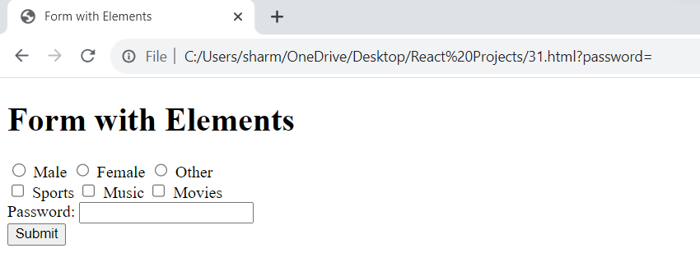

31.b
Objective:
To enhance the visual appearance and user experience of links on a webpage by applying different styles based on their state (normal, hover, active, visited, focus).
HTML Structure:
HTML
<!DOCTYPE html>
<html>
<head>
<title>Pseudo-Class Example</title>
<link rel="stylesheet" href="styles.css">
</head>
<body>
<a href="https://www.example.com">Visit Example</a>
</body>
</html>
CSS (styles.css):
CSS
a {
color: blue;
text-decoration: none;
}

a:hover {
color: red;
text-decoration: underline;
}

a:active {
color: green;
}

a:visited {
color: purple;
}

a:focus {
outline: 2px solid blue;
}
Explanation:
- HTML Structure:
  - Creates a basic HTML structure with a link element.
  - Links the external stylesheet "styles.css".
- CSS Styling:
  - a: Applies default styles to all anchor elements (links). Sets the color to blue and removes the default underline.
  - a:hover: Styles the link when the mouse hovers over it. Changes the color to red and adds an underline.
  - a:active: Styles the link while it's being clicked (activated). Changes the color to green.
  - a:visited: Styles links that have already been visited. Changes the color to purple.
  - a:focus: Styles the link when it has focus (usually when tabbed to). Adds a blue outline.
By incorporating this CSS into your HTML, you will create links with enhanced visual feedback for users, improving the overall user experience.
Additional Notes:
- You can apply these pseudo-classes to other elements besides links, such as buttons.
- Consider using more specific selectors (e.g., .button:hover) for better control over styles.
- Always test your styles across different browsers to ensure consistent behavior.
By understanding and utilizing pseudo-classes, you can create dynamic and interactive web pages that respond to user interactions.

PROGRAM 32
Add CSS property assign a style or behaviour to an HTML element such as: color, border, margin and font-style.

<!DOCTYPE html>
<html>

<head>
<title>CSS Properties Example</title>
</head>

<body>
<h1 style="color: blue;
border: 2px solid red;
margin: 20px;
font-style: italic;">CSS Properties Example</h1>
<p style="color: green;
border: 1px solid black;
margin: 10px;
font-style: normal">This is a paragraph with custom styles.</p>
</body>

</html>

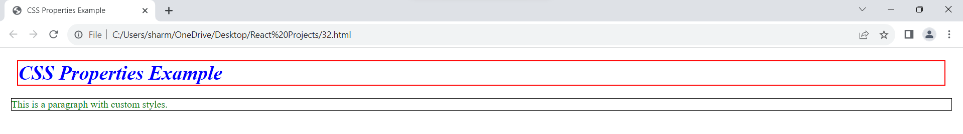

PROGRAM 33
Add To Style Text Elements with Font, Size, and Color in CSS .

index.html (HTML file):

<!DOCTYPE html>
<html>
<head>
<title>Text Styling Example</title>
<link rel="stylesheet" type="text/css" href="styles3.css">
</head>
<body>
<h1 class="title">Welcome to our website</h1>
<p class="paragraph">This is a sample paragraph with styled text.</p>
</body>
</html>

styles3.css (CSS file):

/* Styles for text elements here .title is selector*/
.title {
font-family: Arial, sans-serif;
font-size: 36px;
color: #0066cc;
}

.paragraph {
font-family: Georgia, serif;
font-size: 18px;
color: #333333;
}

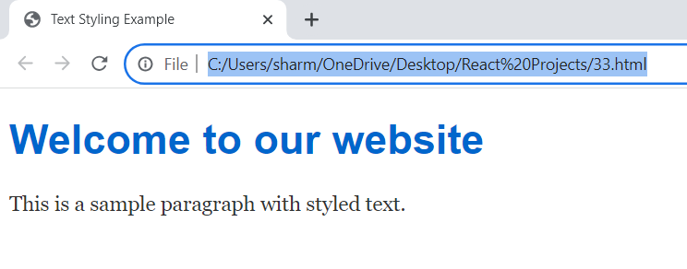

PROGRAM 34
Applying a block element in CSS acquires up the full width available for that content.

<!DOCTYPE html>
<html>
<head>
<title>Block Element Example</title>
<style>
/* Styling for the block-level element */

.block-element {
background-color: #f0f0f0;
border: 1px solid #ddd;
padding: 10px;
/* The following properties ensure the element takes up the full width available */
display: block;
width: 100%;
box-sizing: border-box;
/* Includes padding and border in the total width */
}
</style>
</head>
<body>
<div class="block-element">
This is a block-level element. It takes up the full width available within its containing block.
</div>
</body>

</html>

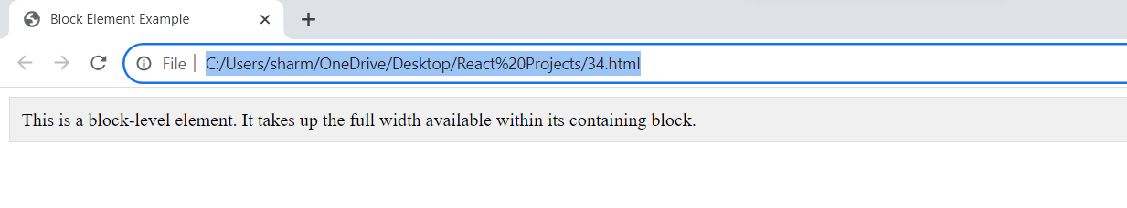

CSS Box Model: Understanding Elements as Boxes
The Box Model Concept
In CSS, every HTML element is treated as a box. This box model consists of four main components:
- Content: The actual content of the element, like text, images, or other elements.
- Padding: The space between the content and the border.
- Border: The edge that surrounds the content and padding.
- Margin: The space outside the border, separating the element from other elements.
Visual Representation
Example
CSS
div {
width: 200px;
height: 100px;
border: 5px solid blue;
padding: 10px;
margin: 20px;
}
In this example:
- The div element has a width of 200px and a height of 100px for its content area.
- A 5px solid blue border surrounds the content and padding.
- There's a 10px space between the content and the border (padding).
- There's a 20px margin around the entire element, separating it from other elements.
Key Properties
- Content:
  - width and height: Specify the dimensions of the content area.
- Padding:
  - padding: Sets the space between the content and the border.
  - padding-top, padding-right, padding-bottom, padding-left: Set padding for specific sides.
- Border:
  - border: Sets the style, width, and color of the border.
  - border-width, border-style, border-color: Set individual border properties.
- Margin:
  - margin: Sets the space outside the border.
  - margin-top, margin-right, margin-bottom, margin-left: Set margin for specific sides.
Box-Sizing Property
The box-sizing property can change how the width and height of an element are calculated.
- box-sizing: content-box; (default): The width and height apply to the content box only.
- box-sizing: border-box;: The width and height apply to the content, padding, and border together.
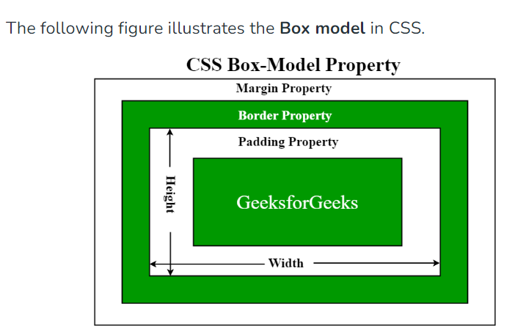
Example with Box-Sizing

CSS
div {
box-sizing: border-box;
width: 200px;
height: 100px;
border: 5px solid blue;
padding: 10px;
}
In this case, the total width of the div will be 200px, including the content, padding, and border.
Understanding the box model is crucial for creating accurate and consistent layouts in CSS.

Why do We Use the div Element in CSS
The div element is a fundamental building block in HTML for creating structure and applying styles using CSS. Here's why it's so widely used:
1. Generic Container
- No inherent meaning: Unlike elements like header, nav, section, or footer, which have semantic meaning, div is a generic container. This flexibility allows you to use it for any purpose in your layout. (semantic elements clearly describes its meaning to both the browser and developer for eg <table> <article > <section> ….. non semantic tells nothing about its content like <span> and <div>)
- Grouping content: You can group related content within a div to apply styles, positioning, or other attributes collectively.
2. Styling and Layout
- Applying CSS: div elements are primarily used as targets for CSS styles. You can apply classes, IDs, or other selectors to div elements to control their appearance, positioning, and behavior.
- Creating layouts: By combining multiple div elements with CSS properties like float, position, display, and flexbox, you can create complex and responsive layouts for your web pages.
3. JavaScript Interaction
- Manipulating content: JavaScript can easily interact with div elements to dynamically modify their content, styles, or positions.
Example
HTML
<div class="container">
<div class="header">This is the header</div>
<div class="content">This is the main content</div>
<div class="footer">This is the footer</div>
</div>
In this example, three div elements are used to create a basic layout for a webpage. You can then apply CSS styles to each div to define their appearance and positioning.
Key Points:
- The div element is a versatile container for structuring content.
- It provides a foundation for applying CSS styles to create various layouts.
- It can be manipulated with JavaScript for dynamic content.
While div is a useful element, it's essential to use it judiciously and consider semantic HTML elements when appropriate to improve accessibility and SEO.

Explain difference between css box model vs css block
CSS Box Model vs. CSS Block: A Clear Distinction
While both terms might seem related, they represent different concepts within CSS:
CSS Box Model
- Conceptual framework: Describes how elements are structured and rendered on a webpage.
- Components: Content, padding, border, and margin.
- Purpose: Determines the overall size and spacing of elements.
- Example: Understanding the box model helps you accurately calculate the total width of an element when setting its width property.
CSS Block
- Syntax: A section of CSS code enclosed in curly braces {}.
- Purpose: Contains declarations that define styles for specific elements or groups of elements.
- Components: Selector, properties, and values.
- Example:
CSS
p {
color: blue;
font-size: 16px;
}
This block applies the styles color: blue; and font-size: 16px; to all paragraph elements (p).
In summary:
- CSS Box Model is a conceptual framework that explains how elements are structured and rendered.
- CSS Block is a syntactic element used to group style declarations for specific elements.
While the box model influences how elements are displayed, CSS blocks are the mechanism through which you apply styles to those elements.

PROGRAM 35
Resize an image to fit its content box, and position the image 5px from the left and 10% from the top inside the content box.

<!DOCTYPE html>
<html>
<head>
<title>Image Resize and Position</title>
<style>
/* Container for the image */

.image-container {
width: 300px;
/* Set the desired width of the content box */
height: 200px;
/* Set the desired height of the content box */
position: relative;
/* Enable positioning for the contained image */
border: 1px solid #ccc;
/* Optional: Add a border for visual reference */
}
/* Styling for the contained image */

.image-container img {
max-width: 100%;
/* Resize the image to fit its content box */
height: auto;
/* Maintain the aspect ratio */
position: absolute;
/* Position the image within the container */
top: 10%;
/* 10% from the top */
left: 5px;
/* 5px from the left */
}
</style>
</head>

<body>
<div class="image-container">
<img src="flower.jpg" alt="Resized and Positioned Image">
</div>
</body>

</html>

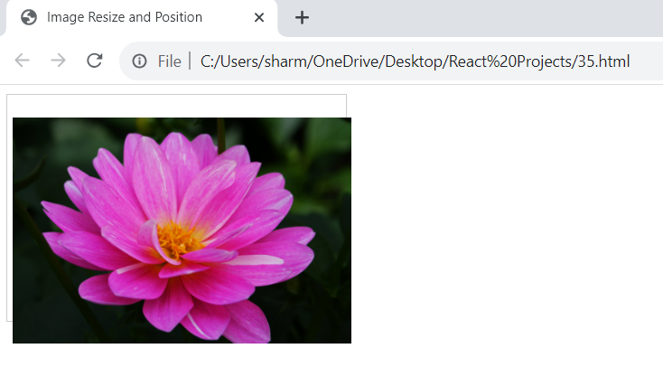

PROGRAM 36
Applying CSS Table: Styling even and odd cells

<!DOCTYPE html>
<html>

<head>
<title>CSS Table: Styling Even and Odd Cells</title>
<style>
/* Style the even rows (tr) */

tr:nth-child(even) {
background-color: #f2f2f2;
}
/* Style the odd rows (tr) */

tr:nth-child(odd) {
background-color: #ffffff;
}
/* Style even cells (td) within even rows */

tr:nth-child(even) td:nth-child(even) {
color: red;
font-weight: bold;
}
/* Style odd cells (td) within odd rows */

tr:nth-child(odd) td:nth-child(odd) {
color: blue;
font-style: italic;
}
</style>
</head>

<body>
<table>
<tr>
<td>Row 1, Cell 1</td>
<td>Row 1, Cell 2</td>
</tr>
<tr>
<td>Row 2, Cell 1</td>
<td>Row 2, Cell 2</td>
</tr>
<tr>
<td>Row 3, Cell 1</td>
<td>Row 3, Cell 2</td>
</tr>
</table>
</body>

</html>

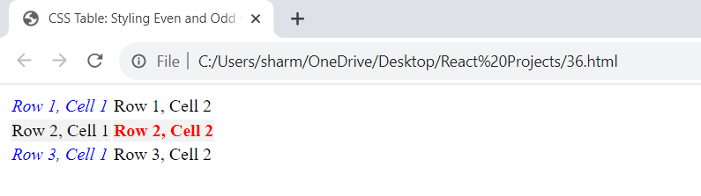

PROGRAM 37
Applying list-style-type property in CSS with example

<!DOCTYPE html>
<html>

<head>
<title>List Style Example</title>
<style>
/* Set the list style type for unordered list */

ul {
list-style-type: square;
/* Using square markers */
}
/* Set the list style type for ordered list */

ol {
list-style-type: upper-roman;
/* Using uppercase Roman numerals */
}
</style>
</head>

<body>
<h2>Unordered List</h2>
<ul>
<li>Item 1</li>
<li>Item 2</li>
<li>Item 3</li>
</ul>

<h2>Ordered List</h2>
<ol>
<li>First item</li>
<li>Second item</li>
<li>Third item</li>
</ol>
</body>

</html>

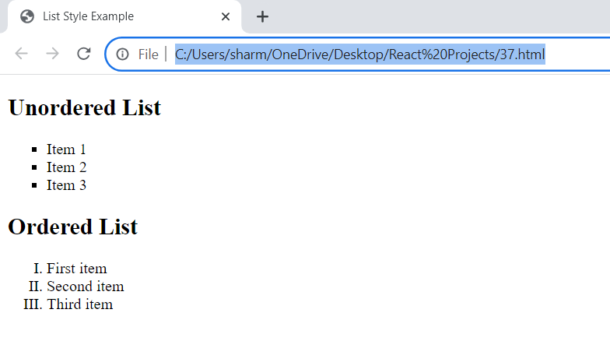

PROGRAM 38
Design a web page by applying css id and class selectors.

Here's the HTML structure:

<!DOCTYPE html>
<html>
<head>
<title>CSS ID and Class Selectors Example</title>
<link rel="stylesheet" type="text/css" href="styles.css">
</head>
<body>
<header>
<h1 id="site-title">My Website</h1>
<nav class="main-menu">
<ul>
<li><a href="#">Home</a></li>
<li><a href="#">About</a></li>
<li><a href="#">Services</a></li>
<li><a href="#">Contact</a></li>
</ul>
</nav>
</header>

<main class="content">
<section>
<h2>Featured Content</h2>
<p>This is the featured content of the website.</p>
</section>
<section>
<h2>Latest News</h2>
<p>Check out the latest news and updates.</p>
</section>
</main>

<footer class="site-footer">
<p>&copy; 2023 My Website. All rights reserved.</p>
</footer>
</body>
</html>

Now, let's create the styles.css file to apply styles using both CSS ID and class selectors:

/* Apply styles to the site title using the ID selector */
#site-title {
font-size: 36px;
color: #333;
}

/* Apply styles to the main navigation menu using the class selector */
.main-menu {
background-color: #f0f0f0;
padding: 10px;
}

.main-menu ul {
list-style-type: none;
margin: 0;
padding: 0;
}

.main-menu li {
display: inline;
margin-right: 15px;
}

.main-menu a {
text-decoration: none;
color: #333;
}

/* Apply styles to the main content area using the class selector */
.content {
padding: 20px;
}

/* Apply styles to the footer using the class selector */
.site-footer {
text-align: center;
padding: 10px;
background-color: #333;
color: #fff;
}

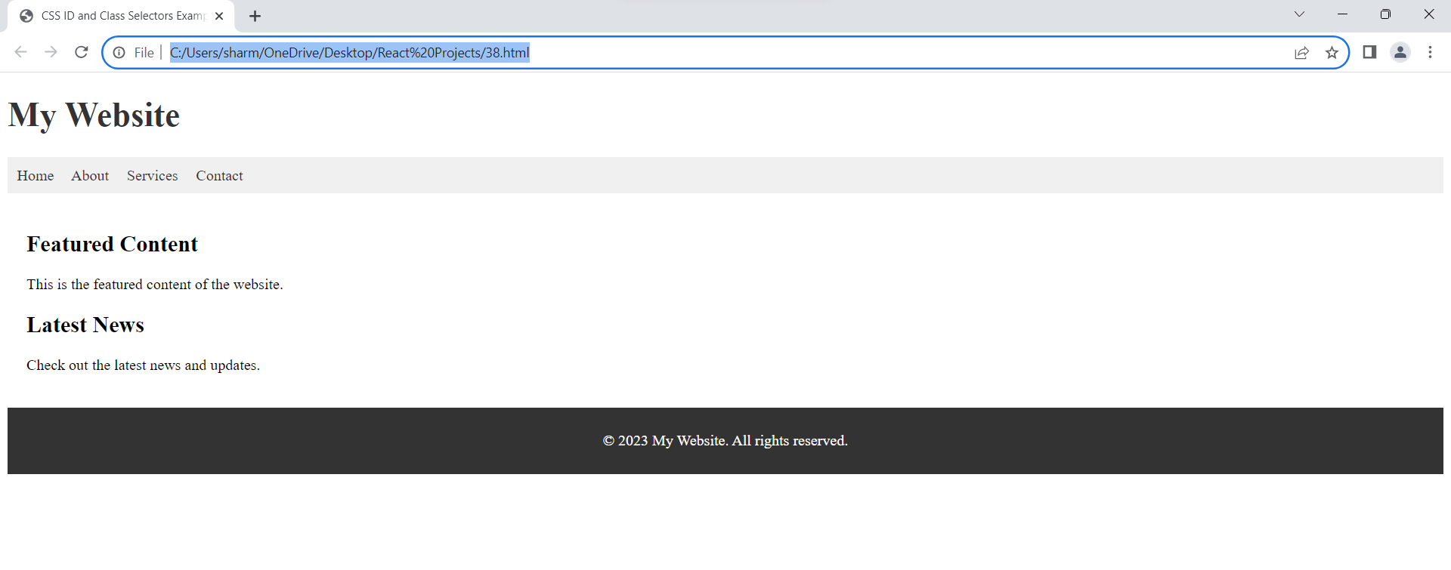

PROGRAM 39
Demonstrating the CSS Box model with consists of: borders, padding, margins, and the actual content.

Here's the HTML structure:

<!DOCTYPE html>
<html>
<head>
<title>CSS Box Model Example</title>
<link rel="stylesheet" type="text/css" href="styles39.css">
</head>
<body>
<div class="box">
This is the content of the box.
</div>
</body>
</html>

Now, let's create the styles39.css file to apply styles and demonstrate the CSS box model:
/* Apply styles to the box */
.box {
width: 200px;
height: 150px;
background-color: #f0f0f0;
border: 2px solid #333;
padding: 20px;
margin: 50px;
}

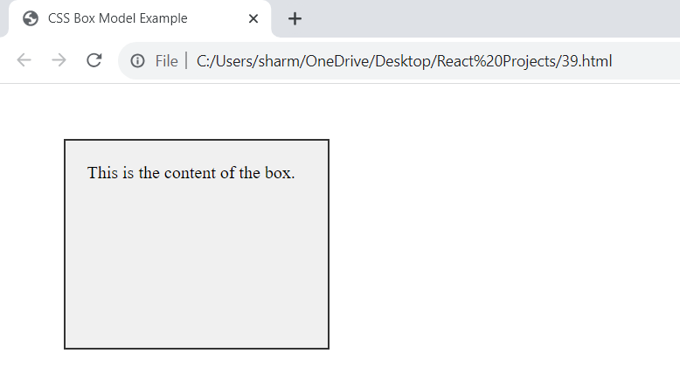

PROGRAM 40
Design a web page by applying CSS grouping and dimensions property.

Here's the HTML structure:

<!DOCTYPE html>
<html>
<head>
<title>CSS Grouping and Dimensions Example</title>
<link rel="stylesheet" type="text/css" href="styles40.css">
</head>
<body>
<header>
<h1>My Website</h1>
</header>

<nav>
<ul>
<li><a href="#">Home</a></li>
<li><a href="#">About</a></li>
<li><a href="#">Services</a></li>
<li><a href="#">Contact</a></li>
</ul>
</nav>

<main>
<section>
<h2>Featured Content</h2>
<p>This is the featured content of the website.</p>
</section>
<section>
<h2>Latest News</h2>
<p>Check out the latest news and updates.</p>
</section>
</main>

<footer>
<p>&copy; 2023 My Website. All rights reserved.</p>
</footer>
</body>
</html>

Now, let's create the styles40.css file to apply styles and control the dimensions of elements using CSS grouping:

/* Apply styles to the header */
header {
background-color: #333;
color: #fff;
text-align: center;
padding: 20px;
}

/* Apply styles to the navigation menu */
nav {
background-color: #f0f0f0;
padding: 10px;
}

nav ul {
list-style-type: none;
margin: 0;
padding: 0;
}

nav li {
display: inline;
margin-right: 15px;
}

nav a {
text-decoration: none;
color: #333;
}

/* Apply styles to the main content area */
main {
padding: 20px;
}

/* Apply styles to the footer */
footer {
background-color: #333;
color: #fff;
text-align: center;
padding: 10px;
}

/* Group the sections inside the main content area */
main section {
margin-bottom: 20px;
}

/* Set dimensions for sections */
section {
width: 45%; /* 45% width for each section */
padding: 10px;
border: 1px solid #ccc;
float: left;
box-sizing: border-box;
}

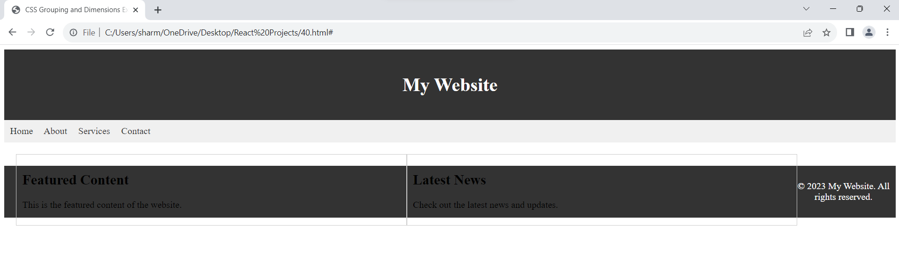

PROGRAM 41
Design a web page by applying CSS Display and Positioning property.
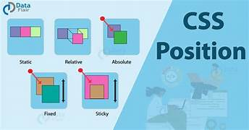

HTML structure:

<!DOCTYPE html>
<html lang="en">
<head>
<meta charset="UTF-8">
<meta name="viewport" content="width=device-width, initial-scale=1.0">
<link rel="stylesheet" href="styles.css">
<title>Simple Layout</title>
</head>
<body>
<header>
<h1>Header</h1>
</header>
<div class="sidebar">
<nav>
<ul>
<li><a href="#">Home</a></li>
<li><a href="#">About</a></li>
<li><a href="#">Services</a></li>
<li><a href="#">Contact</a></li>
</ul>
</nav>
</div>
<main>
<h2>Main Content</h2>
<p>This is the main content area.</p>
</main>
</body>
</html>

CSS (styles.css):

/* Reset some default styles for the body */
body {
margin: 0;
padding: 0;
}

/* Style the header */
header {
background-color: #333;
color: white;
text-align: center;
padding: 10px;
position: fixed;
top: 0;
left: 0;
width: 100%;
}

/* Style the sidebar */
.sidebar {
background-color: #f1f1f1;
height: 100%;
width: 250px;
position: fixed;
top: 60px; /* Height of the header */
left: 0;
overflow-x: hidden;
padding-top: 20px;
}

/* Style the sidebar links */
.sidebar nav ul {
list-style-type: none;
padding: 0;
}

.sidebar nav ul li {
margin-bottom: 10px;
}

/* Style the main content */
main {
margin-left: 250px; /* Width of the sidebar */
padding: 20px;
margin-top: 80px; /* Height of the header + some spacing */
}

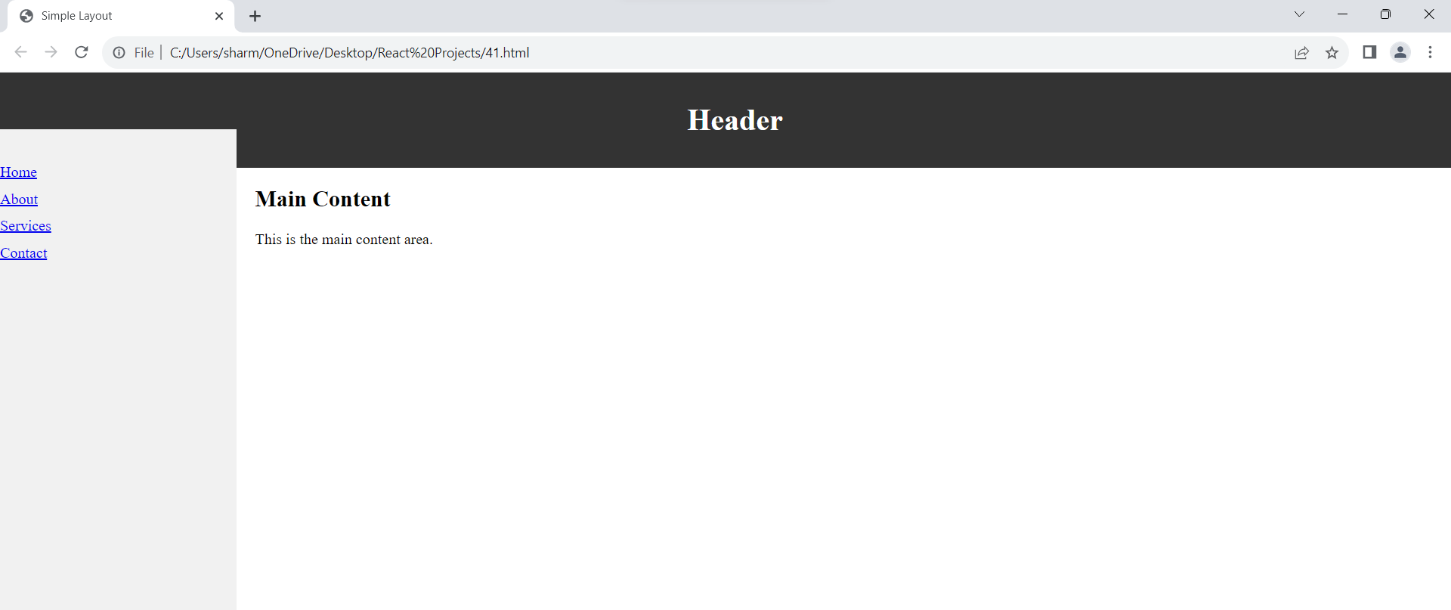

Understanding the Code: CSS Display and Positioning
HTML Structure
- Basic layout: The HTML defines three main sections: header, sidebar, and main.
  - header: Contains the page title.
  - sidebar: Holds the navigation links.
  - main: Contains the primary content.
CSS Styles
Resetting Default Styles
- body { margin: 0; padding: 0; }: Removes default browser margins and padding to ensure consistent styling.
Styling the Header
- header: Styles the header element.
  - background-color, color, text-align, and padding: Basic styling for the header's appearance.
  - position: fixed;: Positions the header at a fixed position on the screen, meaning it stays in place even when the user scrolls.
  - top: 0; left: 0; width: 100%;: Places the header at the top left corner and makes it full width.
Styling the Sidebar
- .sidebar: Styles the sidebar element.
  - background-color: Sets the background color.
  - height: 100%;: Makes the sidebar full height of the viewport.
  - width: Sets the width of the sidebar.
  - position: fixed;: Positions the sidebar at a fixed position on the screen, similar to the header.
  - top, left, and overflow-x: Position the sidebar below the header and prevent horizontal scrolling.
  - padding-top: Adds spacing at the top of the sidebar.
Styling the Sidebar Links
- .sidebar nav ul: Styles the unordered list within the sidebar navigation.
  - Removes default list styles.
- .sidebar nav ul li: Styles the list items in the sidebar navigation.
  - Adds spacing between list items.
Styling the Main Content
- main: Styles the main content area.
  - margin-left: Positions the main content to the right of the sidebar.
  - padding: Adds spacing around the main content.
  - margin-top: Positions the main content below the header with some spacing.
Key CSS Properties and Their Roles
- display: Not explicitly used in this code, but it controls how an element is displayed (e.g., inline, block, flex, grid).
- position: Determines the positioning of an element (e.g., static, relative, absolute, fixed).
  - fixed: Used for the header and sidebar to create a fixed layout.
- float: Not used here, but it can be used to position elements side by side.
- clear: Not used here, but it can be used to prevent elements from floating next to each other.
Overall Layout
This code creates a basic layout with a fixed header, a fixed sidebar, and the main content area taking up the remaining space. The CSS properties used effectively position and style these elements to achieve the desired layout.

Explain CSS Positioning: Controlling Element Placement
CSS positioning allows you to precisely control the placement of elements on a webpage. It involves using the position property and its associated properties like top, right, bottom, and left.
The position Property
The position property specifies the type of positioning applied to an element. It has five main values:
- static: (default)
  - Elements are positioned according to the normal flow of the document.
  - top, right, bottom, and left properties have no effect.
- relative:
  - Elements are positioned relative to their normal position.
  - top, right, bottom, and left properties offset the element from its original position.
  - The element still takes up its original space in the document flow.
- absolute:
  - Elements are positioned relative to the nearest positioned ancestor (not static).
  - If there's no positioned ancestor, the element is positioned relative to the viewport.
  - The element is removed from the normal document flow.
- fixed:
  - Elements are positioned relative to the viewport.
  - They remain fixed in their position even if the page is scrolled.
- sticky:
  - Elements are positioned relative to the viewport until they reach a specified offset, then they become fixed.
  - This is a combination of relative and fixed positioning.
Additional Properties
- top: Sets the top position of an element.
- right: Sets the right position of an element.
- bottom: Sets the bottom position of an element.
- left: Sets the left position of an element.
- z-index: Specifies the stacking order of elements.
Example
CSS
.element {
position: absolute;
top: 50px;
left: 100px;
}

This code positions an element with the class "element" absolutely, placing it 50 pixels from the top and 100 pixels from the left of its nearest positioned ancestor or the viewport.
Visual Representation

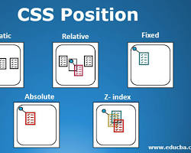

different positioning methods in CSS
Key Points
- Choose the appropriate positioning method based on your desired layout.
- Use top, right, bottom, and left to fine-tune the element's position.
- Be aware of the impact of positioning on other elements in the document.
- Consider using z-index to control the stacking order of overlapping elements.
By understanding these concepts, you can create complex and dynamic layouts for your web pages.

PROGRAM 42
Design a web page showing the use of inline, internal and external CSS.

HTML structure:

<!DOCTYPE html>
<html lang="en">
<head>
<meta charset="UTF-8">
<meta name="viewport" content="width=device-width, initial-scale=1.0">
<link rel="stylesheet" href="styles.css">
<title>CSS Examples</title>
</head>
<body>
<h1>This is a Heading</h1>

<!-- Inline CSS -->
<p style="color: red;">This is a paragraph with inline CSS.</p>

<p>This is a paragraph with internal CSS.</p>

<p class="external-css">This is a paragraph with external CSS.</p>
</body>
</html>

CSS (internal):

/* Internal CSS */
p {
font-size: 18px;
line-height: 1.6;
}

CSS (external - styles.css):

/* External CSS */
.external-css {
font-weight: bold;
color: blue;
}

Explanation
Understanding the Code: Inline, Internal, and External CSS
HTML Structure
- <!DOCTYPE html>: Declares the document type as HTML5.
- <html lang="en">: Defines the root of the HTML document and specifies the language as English.
- <head>: Contains meta-information about the document.
  - <meta charset="UTF-8">: Specifies the character encoding as UTF-8.
  - <meta name="viewport" content="width=device-width, initial-scale=1.0">: Sets the viewport for optimal viewing on different devices.
  - <link rel="stylesheet" href="styles.css">: Links an external CSS file named "styles.css".
  - <title>CSS Examples</title>: Sets the title of the webpage.
- <body>: Contains the visible content of the webpage.
  - <h1>This is a Heading</h1>: Creates a heading level 1.
  - <p style="color: red;">This is a paragraph with inline CSS.</p>: Creates a paragraph with inline CSS, setting the text color to red.
  - <p>This is a paragraph with internal CSS.</p>: Creates a paragraph that will be styled by internal CSS.
  - <p class="external-css">This is a paragraph with external CSS.</p>: Creates a paragraph with a class "external-css" that will be styled by external CSS.
CSS (Internal)
- / Internal CSS */*: A comment indicating internal CSS.
- p: Selects all paragraph elements.
  - font-size: 18px;: Sets the font size of paragraphs to 18 pixels.
  - line-height: 1.6;: Sets the line height of paragraphs to 1.6 times the font size.
CSS (External - styles.css)
- / External CSS */*: A comment indicating external CSS.
- .external-css: Selects elements with the class "external-css".
  - font-weight: bold;: Sets the font weight of elements with the class "external-css" to bold.
  - color: blue;: Sets the color of elements with the class "external-css" to blue.
Explanation of CSS Types
Inline CSS
- Applied directly to an HTML element using the style attribute.
- It's often used for quick styling adjustments but is generally discouraged for larger stylesheets due to poor maintainability.
Internal CSS
- Embedded within the <head> section of the HTML document using the <style> tag.
- It's suitable for small stylesheets or styling elements within a specific page.
External CSS
- Linked to the HTML document using the <link> tag in the <head> section.
- It's the preferred method for larger stylesheets as it improves organization, maintainability, and reusability.
In this example:
- The first paragraph uses inline CSS to set the text color to red.
- The second paragraph uses internal CSS to set the font size and line height.
- The third paragraph uses external CSS to set the font weight and color.
By combining these three methods, you can effectively style your web pages based on the specific needs of your project.

PROGRAM 43
One eg link https://youtu.be/GrOy_UmmAqw?si=_bxxaCDlD_aw7_gG

Design a web page by applying CSS pseudo classes.

HTML structure:

<!DOCTYPE html>
<html lang="en">
<head>
<meta charset="UTF-8">
<meta name="viewport" content="width=device-width, initial-scale=1.0">
<link rel="stylesheet" href="styles.css">
<title>CSS Pseudo-Classes Example</title>
</head>
<body>
<nav>
<ul>
<li><a href="#">Home</a></li>
<li><a href="#">About</a></li>
<li><a href="#">Services</a></li>
<li><a href="#">Contact</a></li>
</ul>
</nav>
</body>
</html>

CSS (styles.css):

/* Basic styles for the navigation menu */
nav ul {
list-style-type: none;
padding: 0;
}

nav ul li {
display: inline;
margin-right: 20px;
}

nav ul li a {
text-decoration: none;
color: #333;
font-weight: bold;
font-size: 18px;
}

/* Pseudo-class for hover effect */
nav ul li a:hover {
color: #0074D9;
}

o/p
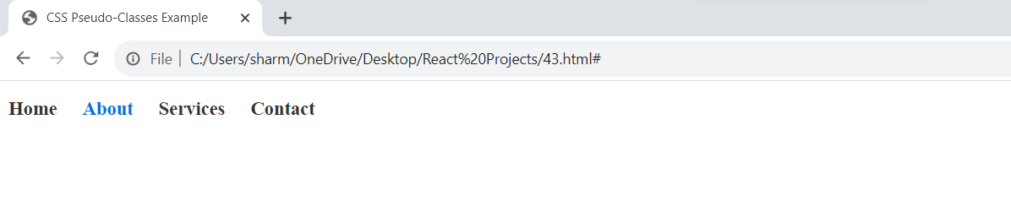

Explanation
- <!DOCTYPE html>: Declares the document type as HTML5.
- <html lang="en">: Defines the root of the HTML document and specifies the language as English.
- <head>: Contains meta-information about the document.
  - <meta charset="UTF-8">: Specifies the character encoding as UTF-8.
  - <meta name="viewport" content="width=device-width, initial-scale=1.0">: Sets the viewport for optimal viewing on different devices.

  - <link rel="stylesheet" href="styles.css">: Links the external CSS file named "styles.css".
  - <title>CSS Pseudo-Classes Example</title>: Sets the title of the webpage.
- <body>: Contains the visible content of the webpage.
  - <nav>: Creates a navigation section.
    - <ul>: Defines an unordered list for the navigation menu items.
      - <li>: List items for each menu item.
        - <a href="#">: Anchor tags for links with placeholder links (#).
CSS Styles
- Basic styles for the navigation menu:
  - nav ul: Styles the unordered list within the navigation section.
    - list-style-type: none;: Removes the default bullet points.
    - padding: 0;: Removes default padding.
  - nav ul li: Styles the list items within the navigation menu.
    - display: inline;: Displays the list items horizontally.
    - margin-right: 20px;: Adds spacing between list items.
  - nav ul li a: Styles the anchor tags within the list items.
    - text-decoration: none;: Removes the default underline from links.
    - color: #333;: Sets the text color to a dark gray.
    - font-weight: bold;: Makes the text bold.
    - font-size: 18px;: Sets the font size to 18 pixels.
- Pseudo-class for hover effect:
  - nav ul li a:hover: Styles the anchor tag when the mouse hovers over it.
    - color: #0074D9;: Changes the text color to a blue color when hovered.
Explanation of the Code
- The HTML structure creates a basic navigation menu with four links: Home, About, Services, and Contact.
- The CSS styles apply basic formatting to the navigation menu, removing default styles and spacing the list items.
- The CSS also defines a hover effect for the anchor tags, changing the text color when the mouse is over a link.
Key Points
- The CSS pseudo-class :hover is used to style an element when the mouse pointer is over it.
- The code demonstrates a simple example of using CSS to create interactive elements on a webpage.

CSS Pseudo-Classes: Styling Based on State
A CSS pseudo-class is a keyword added to a selector that specifies a special state of the selected element(s).
Hover, active, focus, visited, link, firstchild , lastchild
In simpler terms, it allows you to style an element based on its current condition or state, without needing to add extra HTML classes.

Common Pseudo-Classes
Here are some of the most commonly used pseudo-classes:
- :hover: Styles an element when the mouse pointer is over it.
CSS
a:hover {
color: blue;
}

- :active: Styles an element while it is being activated by a user action (usually a mouse click).
CSS
button:active {
background-color: red;
}

- :focus: Styles an element when it has focus (typically when it's selected by a keyboard).
CSS
input:focus {
outline: 2px solid blue;
}

- :visited: Styles an element that has been linked to before.
CSS
a:visited {
color: purple;
}

- :link: Styles an unvisited link.
CSS
a:link {
color: green;
}

- :first-child: Selects the first child element of its parent.
CSS
p:first-child {
font-weight: bold;
}

- :last-child: Selects the last child element of its parent.
CSS
li:last-child {
border-bottom: none;
}

Example: Creating a Hover Effect
HTML
<a href="#">Hover over me</a>
CSS
a:hover {
color: red;
text-decoration: underline;
}

When you hover over the link, the text color will change to red, and an underline will appear.
Key Points
- Pseudo-classes start with a colon (:).
- They allow you to create dynamic styles based on user interaction or element state.
- They can be combined with other selectors for more specific targeting.
By using pseudo-classes effectively, you can create interactive and user-friendly web pages.

PROGRAM 44
Design a web page by applying CSS Navigation Bar.

HTML structure:

<!DOCTYPE html>
<html lang="en">
<head>
<meta charset="UTF-8">
<meta name="viewport" content="width=device-width, initial-scale=1.0">
<link rel="stylesheet" href="styles.css">
<title>CSS Navigation Bar Example</title>
</head>
<body>
<nav class="navbar">
<ul>
<li><a href="#">Home</a></li>
<li><a href="#">About</a></li>
<li><a href="#">Services</a></li>
<li><a href="#">Portfolio</a></li>
<li><a href="#">Contact</a></li>
</ul>
</nav>
</body>
</html>

CSS (styles.css):

/* Basic styles for the navigation bar */
.navbar {
background-color: #333;
overflow: hidden;
}

.navbar ul {
list-style-type: none;
margin: 0;
padding: 0;
}

.navbar li {
float: left;
margin-right: 20px;
}

.navbar li a {
display: block;
color: white;
text-align: center;
padding: 14px 16px;
text-decoration: none;
transition: background-color 0.3s ease;
}

/* Hover effect */
.navbar li a:hover {
background-color: #0074D9;
}

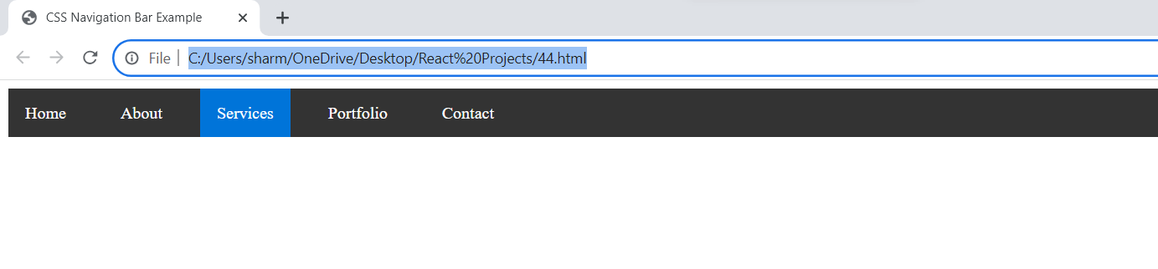

PROGRAM 45
Design a web page such as home page, contact us, about us etc. by using 3 ways of CSS layout.

HTML Structure:

<!DOCTYPE html>
<html lang="en">
<head>
<meta charset="UTF-8">
<meta name="viewport" content="width=device-width, initial-scale=1.0">
<link rel="stylesheet" href="styles.css">
<title>Layout Examples</title>
</head>
<body>
<header>
<h1>My Website</h1>
<nav>
<ul>
<li><a href="#">Home</a></li>
<li><a href="#">About Us</a></li>
<li><a href="#">Contact Us</a></li>
</ul>
</nav>
</header>

<div class="content">
<section class="home">
<h2>Home Page</h2>
<p>Welcome to our website! This is the home page content.</p>
</section>

<section class="about">
<h2>About Us</h2>
<p>We are a passionate team with a mission to...</p>
</section>

<section class="contact">
<h2>Contact Us</h2>
<p>Feel free to reach out to us at contact@example.com</p>
</section>
</div>
</body>
</html>

CSS (styles.css):

Floats Layout:

/* Floats Layout */
.content {
overflow: hidden;
}

section {
float: left;
width: 33.33%;
box-sizing: border-box;
padding: 20px;
}

/* Additional styles for navigation */
nav ul {
list-style-type: none;
margin: 0;
padding: 0;
}

nav ul li {
display: inline;
margin-right: 20px;
}

Flexbox Layout:

/* Flexbox Layout */
.content {
display: flex;
flex-wrap: wrap;
justify-content: space-around;
}

section {
flex: 0 0 calc(33.33% - 40px);
box-sizing: border-box;
padding: 20px;
}

CSS Grid Layout:

/* CSS Grid Layout */
.content {
display: grid;
grid-template-columns: repeat(3, 1fr);
grid-gap: 20px;
}

section {
box-sizing: border-box;
padding: 20px;
}

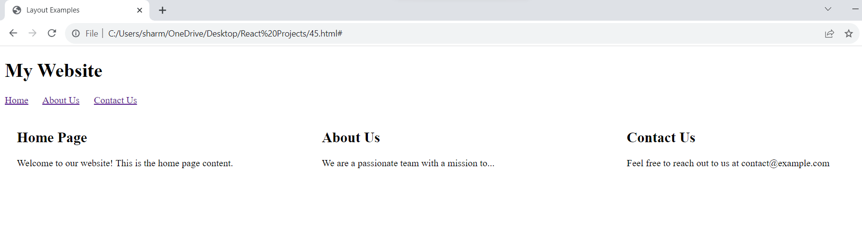

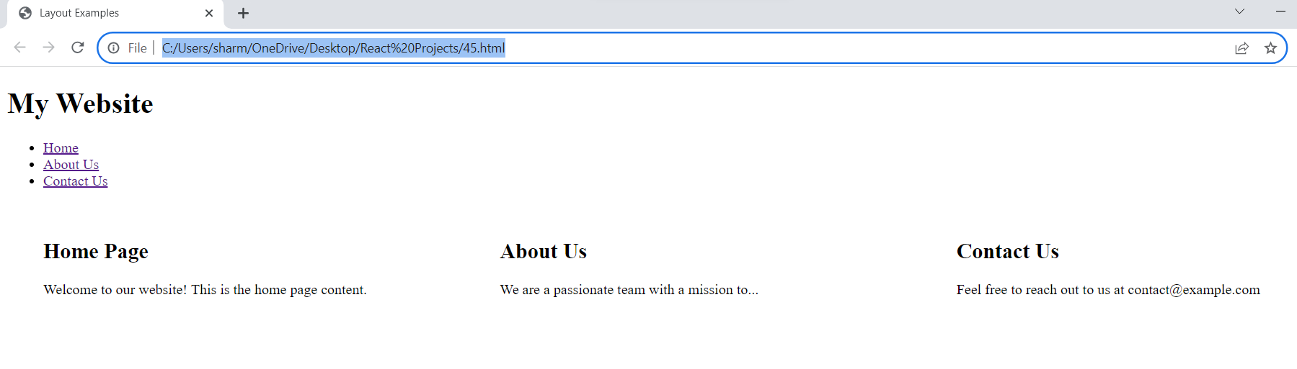

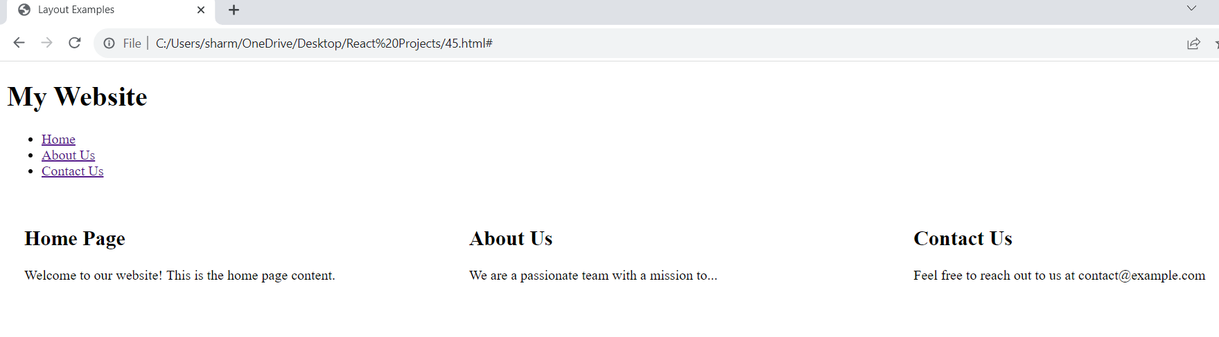

PROGRAM 46
Design a basic structure of Bootstrap Grid system.

<!DOCTYPE html>
<html lang="en">
<head>
<meta charset="UTF-8">
<meta name="viewport" content="width=device-width, initial-scale=1.0">
<title>Bootstrap Grid Example</title>
<!-- Link to Bootstrap CSS -->
<link rel="stylesheet" href="https://maxcdn.bootstrapcdn.com/bootstrap/4.5.2/css/bootstrap.min.css">
</head>
<body>
<div class="container">
<div class="row">
<div class="col-md-4">
<!-- Column content here -->
<p>This is column 1</p>
</div>
<div class="col-md-4">
<!-- Column content here -->
<p>This is column 2</p>
</div>
<div class="col-md-4">
<!-- Column content here -->
<p>This is column 3</p>
</div>
</div>
</div>

<!-- Link to Bootstrap JS (optional) -->
<script src="https://ajax.googleapis.com/ajax/libs/jquery/3.5.1/jquery.min.js"></script>
<script src="https://cdnjs.cloudflare.com/ajax/libs/popper.js/1.16.0/umd/popper.min.js"></script>
<script src="https://maxcdn.bootstrapcdn.com/bootstrap/4.5.2/js/bootstrap.min.js"></script>
</body>
</html>

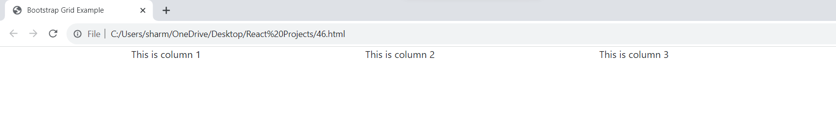
PROGRAM 47
Design All Bootstrap Components with example.

Typography and Headings
Example: Creating a heading with a responsive text size.

<!DOCTYPE html>
<html>
<head>
<link rel="stylesheet" href="https://maxcdn.bootstrapcdn.com/bootstrap/4.5.2/css/bootstrap.min.css">
</head>
<body>
<div class="container">
<h1 class="display-4">Bootstrap Typography</h1>
<p class="lead">This is an example of Bootstrap typography.</p>
<p class="text-muted">This is a muted text.</p>
<p class="text-danger">This is a danger text.</p>
</div>
<script src="https://ajax.googleapis.com/ajax/libs/jquery/3.5.1/jquery.min.js"></script>
<script src="https://cdnjs.cloudflare.com/ajax/libs/popper.js/1.16.0/umd/popper.min.js"></script>
<script src="https://maxcdn.bootstrapcdn.com/bootstrap/4.5.2/js/bootstrap.min.js"></script>
</body>
</html>

Buttons
Example: Creating different types of buttons.

<!DOCTYPE html>
<html>
<head>
<link rel="stylesheet" href="https://maxcdn.bootstrapcdn.com/bootstrap/4.5.2/css/bootstrap.min.css">
</head>
<body>
<div class="container">
<button class="btn btn-primary">Primary Button</button>
<button class="btn btn-success">Success Button</button>
<button class="btn btn-danger">Danger Button</button>
<button class="btn btn-outline-secondary">Outline Secondary Button</button>
</div>
<script src="https://ajax.googleapis.com/ajax/libs/jquery/3.5.1/jquery.min.js"></script>
<script src="https://cdnjs.cloudflare.com/ajax/libs/popper.js/1.16.0/umd/popper.min.js"></script>
<script src="https://maxcdn.bootstrapcdn.com/bootstrap/4.5.2/js/bootstrap.min.js"></script>
</body>
</html>

Navigation Bar
Example: Creating a responsive navigation bar.

<!DOCTYPE html>
<html>
<head>
<link rel="stylesheet" href="https://maxcdn.bootstrapcdn.com/bootstrap/4.5.2/css/bootstrap.min.css">
</head>
<body>
<nav class="navbar navbar-expand-lg navbar-light bg-light">
<a class="navbar-brand" href="#">Navbar</a>
<button class="navbar-toggler" type="button" data-toggle="collapse" data-target="#navbarNav"
aria-controls="navbarNav" aria-expanded="false" aria-label="Toggle navigation">
<span class="navbar-toggler-icon"></span>
</button>
<div class="collapse navbar-collapse" id="navbarNav">
<ul class="navbar-nav">
<li class="nav-item active">
<a class="nav-link" href="#">Home <span class="sr-only">(current)</span></a>
</li>
<li class="nav-item">
<a class="nav-link" href="#">Features</a>
</li>
<li class="nav-item">
<a class="nav-link" href="#">Pricing</a>
</li>
</ul>
</div>
</nav>
<script src="https://ajax.googleapis.com/ajax/libs/jquery/3.5.1/jquery.min.js"></script>
<script src="https://cdnjs.cloudflare.com/ajax/libs/popper.js/1.16.0/umd/popper.min.js"></script>
<script src="https://maxcdn.bootstrapcdn.com/bootstrap/4.5.2/js/bootstrap.min.js"></script>
</body>
</html>

Alerts
Example: Creating different types of alert messages.

<!DOCTYPE html>
<html>
<head>
<link rel="stylesheet" href="https://maxcdn.bootstrapcdn.com/bootstrap/4.5.2/css/bootstrap.min.css">
</head>
<body>
<div class="container">
<div class="alert alert-primary" role="alert">
This is a primary alert.
</div>
<div class="alert alert-success" role="alert">
This is a success alert.
</div>
<div class="alert alert-danger" role="alert">
This is a danger alert.
</div>
</div>
<script src="https://ajax.googleapis.com/ajax/libs/jquery/3.5.1/jquery.min.js"></script>
<script src="https://cdnjs.cloudflare.com/ajax/libs/popper.js/1.16.0/umd/popper.min.js"></script>
<script src="https://maxcdn.bootstrapcdn.com/bootstrap/4.5.2/js/bootstrap.min.js"></script>
</body>
</html>

Cards
Example: Creating a simple card with an image.

<!DOCTYPE html>
<html>
<head>
<link rel="stylesheet" href="https://maxcdn.bootstrapcdn.com/bootstrap/4.5.2/css/bootstrap.min.css">
</head>
<body>
<div class="container">
<div class="card" style="width: 18rem;">
<img src="https://via.placeholder.com/150" class="card-img-top" alt="...">
<div class="card-body">
<h5 class="card-title">Card Title</h5>
<p class="card-text">This is a simple card with some text content.</p>
<a href="#" class="btn btn-primary">Go somewhere</a>
</div>
</div>
</div>
<script src="https://ajax.googleapis.com/ajax/libs/jquery/3.5.1/jquery.min.js"></script>
<script src="https://cdnjs.cloudflare.com/ajax/libs/popper.js/1.16.0/umd/popper.min.js"></script>
<script src="https://maxcdn.bootstrapcdn.com/bootstrap/4.5.2/js/bootstrap.min.js"></script>
</body>
</html>

